Qcells CORE Pro Installer Application: Technical Design Document

1. System Overview

1.1 ESS State-Driven Installation Workflow
The installation workflow is split into 3 stages: server pre-sync → on-site offline configuration → post-installation sync
- Stage 1. Pre-Sync
  - After login, receive today's work orders based on the installer ID
  - Download Serial No, NMI No, model info, and the latest firmware binary of target ESS units to local storage
  - Subsequent stages proceed regardless of on-site internet connectivity
- Stage 2. Offline-First Commissioning
  - All configuration I/O performed over a BLE 1:1 direct link between the app and the device
  - Operates on the device's own data without server round trips
  - Firmware update performed over 1:1 communication with the ESS built-in Wi-Fi
- Stage 3. Completion & Cloud Sync
  - Device state confirmed as Incomplete → Run at the moment of Apply
  - Change history stored as in-app Transactions with unique IDs
  - Change history automatically synced to the cloud when internet connectivity is restored
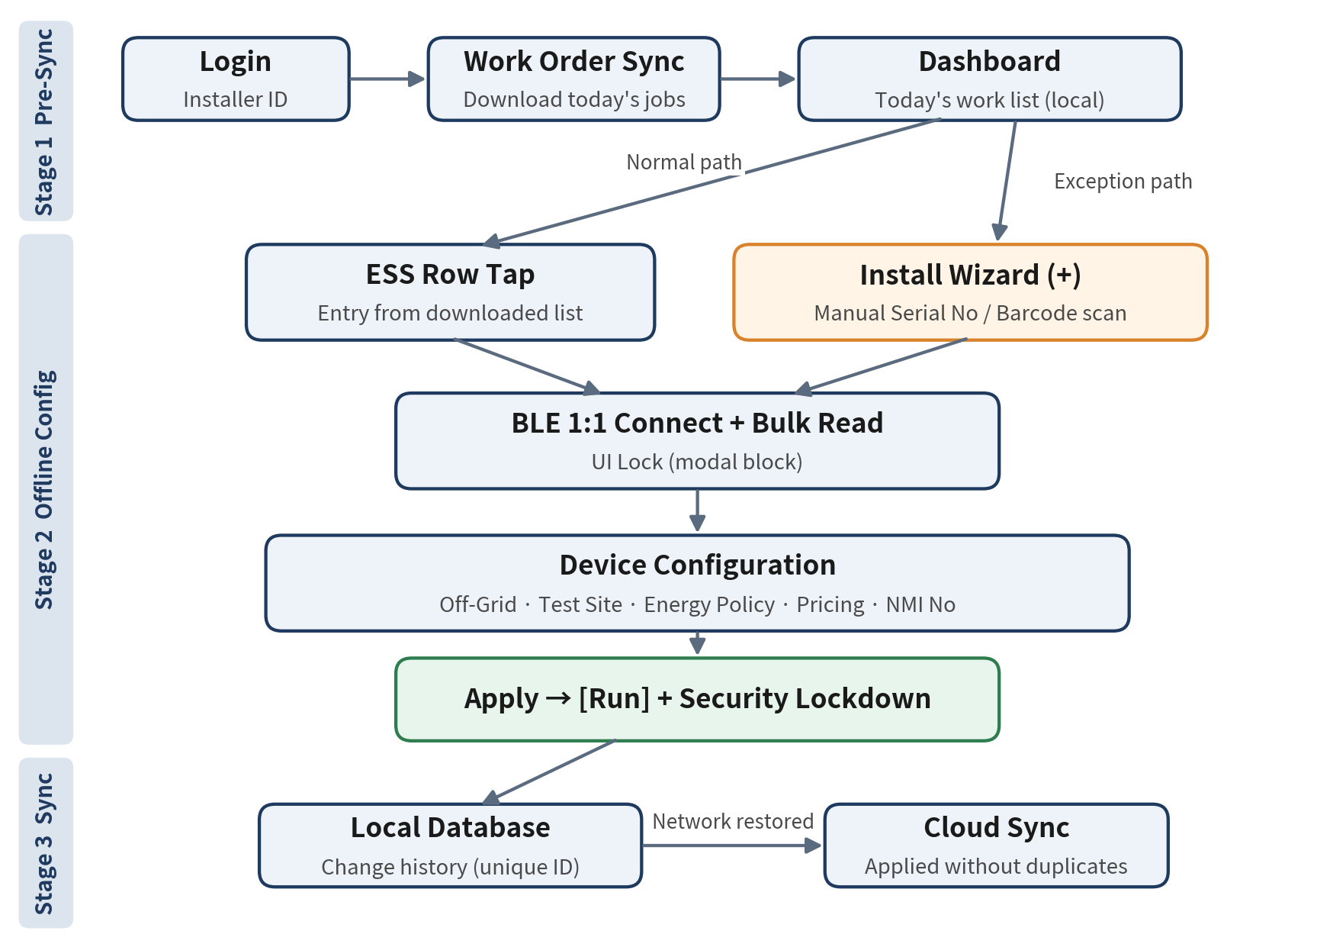
Figure 1. ESS Installation Workflow

1.2 Core ESS State Definitions
All screen permissions and editable scope in the app are determined by the following 4 states
State | Definition | Field Meaning | App Permission Policy
Incomplete | Factory reset state, configuration not completed | New installation target | Password bypass, full configuration editing allowed
Run | In commercial operation after configuration | Maintenance / reconfiguration target | Status view only, temporary password authentication required to configure
Warning / Error | Device self-diagnosis warning or halt | Field troubleshooting target | Diagnostic data first, configuration changes follow operating policy
Wifi / non-Wifi | Whether the device has external internet access | Whether cloud remote monitoring is available | Shows local storage sync pending when non-Wifi

- Wifi / non-Wifi is an independent connectivity state combined with the states above (e.g. Run + non-Wifi = operating normally but not reporting to the cloud)
- FW Updating is an app session state, not a device state, returning to Run on the new version on Commit or on the previous version on Rollback
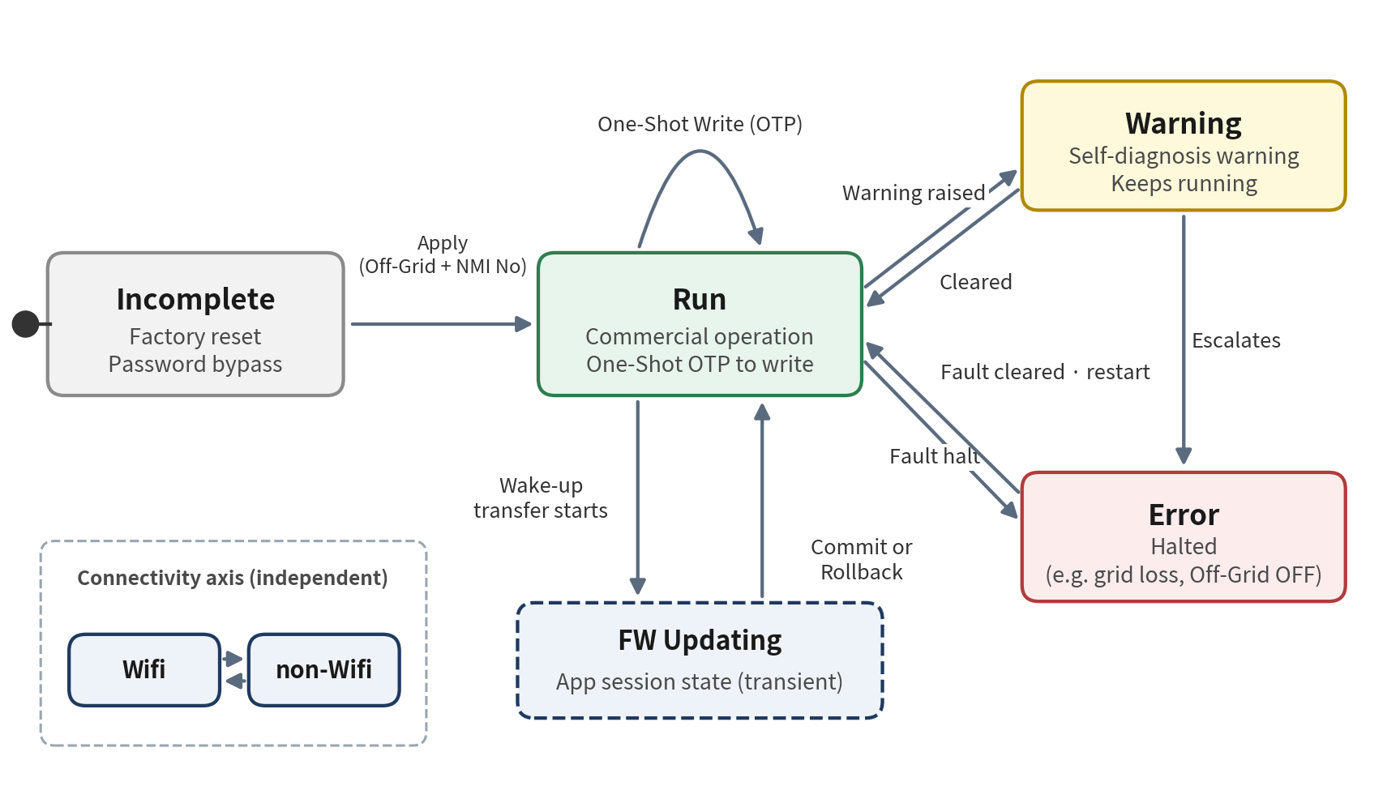
Figure 2. ESS State Transition Diagram

1.3 Confirmed Behaviors and Assumptions
Defines 7 field behaviors confirmed by reverse-engineering the UX spec and their design interpretation
① What the Dashboard List Really Is
- Not a live BLE scan list, but today's work list downloaded/synced based on the installer ID
- Design: Dashboard rendering fully decoupled from BLE state, offline mode guaranteed via local storage
② Install Wizard (+) Button
- Manual entry point dedicated to exceptions not covered by the download
- Cases: visits to households missing from the system, mismatches caused by on-site hardware replacement
- Installer manually enters or barcode-scans the Serial No of the physical device
- Design: Entered Serial No used as the BLE Local Name matching key to establish a 1:1 direct link, entry history recorded to the server
③ UI Lock on Detail Entry and Refresh
- BLE 1:1 connection and real-time Bulk Read occur simultaneously when an ESS Row is tapped
- All UI interaction forcibly blocked with a modal during refresh to prevent command collisions
- Device internal data force-refreshed in real time over a local BLE / socket direct link, not a server call
- Design: Session-scoped single Command Queue and Modal Lock Guard (see 2.1)
④ Permissions in Incomplete State
- Factory reset state has no password to protect, so the Temporary Installer Password step is fully bypassed
- Sequence: set the Off-Grid safety interlock at the top → enter NMI No at the bottom → Apply
- On Apply, the final [Run] state is confirmed and the device switches to security Lockdown mode
- Design: Apply treated as an irreversible transaction, mandatory confirmation dialog and settings summary screen
⑤ NMI No Cannot Be Re-entered After Deletion
- Deleting an existing NMI No on the edit screen of an uninstalled unit causes a Runtime Lockout that blocks manual re-entry
- Cause: NMI No is not a value the installer creates, but a unique asset issued and looked up via the server / settlement network (Read-Only Subscribed Asset)
- Design
  - NMI No field redefined as a Lookup Picker instead of free text input, with a "Re-fetch" action instead of delete
  - NMI No preloaded into work orders during pre-sync to prepare for offline conditions
⑥ Energy Policy and Pricing Menu Linkage
- In normal Standby mode, no tariff table is needed, so access to the Pricing submenu is fully blocked
- Pricing input form (manual per-kWh rate) unlocked only at runtime when switched to [Time-based Mode] in the top settings
- Design: Pricing availability determined by the device's own data, not local UI state
⑦ Hardware Master Switch Definitions
- Off-Grid
  - Safety unlock switch deciding whether to run standalone on solar and battery instead of halting with an error when the external grid is lost
  - Misconfiguration directly affects human / equipment safety, so a 2-step confirmation UI is applied
- Test Site
  - Whether the unit is an experimental asset for communication testing before commercial operation, when Yes the backend excludes its metering data from the general billing statistics pipeline
  - Warning banner shown just before Run confirmation to prevent forgetting to switch to No for commercial operation

1.4 Key Error and Recovery Paths
Every error uses device Read-back as the final source of truth, so no job ends with the app and device out of sync
Situation | Detection | Recovery
BLE drop during Bulk Read | didDisconnectPeripheral, pending Continuations thrown | Release UI Lock, auto-reconnect once, then offer retry to the installer
Write response Timeout | No Write With Response ack | No automatic resend, reconnect and compare Read-back, resend with a new OTP only if not applied
OTP verification failure | Device error code | Check device clock and prompt re-entry, show remaining Lockout time after consecutive failures
Interrupted Apply | Local incomplete marker saved before Apply | On re-entry read device state, mark complete if Run, re-Apply after settings summary if Incomplete
App killed / device power loss during Flash | FW session marker found on relaunch | Read device version, Commit if new version, confirm Rollback and retry if previous version
SoftAP join failure | NEHotspotConfiguration error | Retry once, then request BLE Wake-up again and reissue SSID
Install Wizard scan failure | No Local Name match within Timeout | Re-check Serial No, guide installer closer (RSSI shown), rescan barcode
Cloud Sync failure | HTTP 5xx / network error | Retry with increasing Timeout, treat 409 duplicate as success

2. Mobile Architecture and Core Interfaces

2.1 Layered Information and Clean Architecture
UI / Domain / Data 3-layer separation isolates hardware spec changes from propagating to the UI
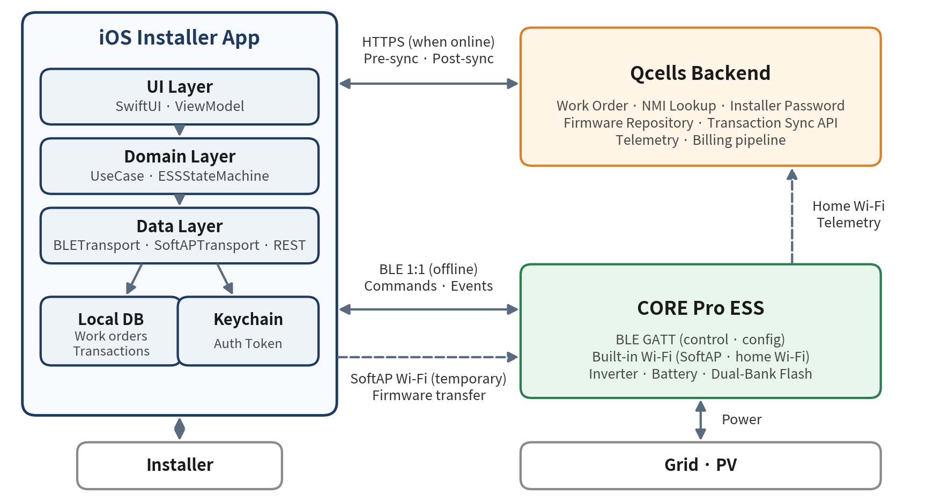
Figure 3. System Context Diagram
Layer | Components | Responsibility
UI Layer | SwiftUI View, @MainActor ViewModel | Screen rendering, UI Lock display, forwarding user actions
Domain Layer | UseCase, Entity, ESSStateMachine | State transition rules, permission policy, Pricing availability
Data Layer | Repository, BLETransport, SoftAPTransport, REST Client, Local Store | Device register I/O, server communication, local persistence

- Dependency Direction
  - UI → Domain ← Data (Domain owns only Protocols)
  - BLETransport defined as a Protocol so Mock / real implementations can be swapped
- Dashboard Refresh Spec
  - Pull-to-Refresh re-syncs the work list with the server
  - Home detail screen Refresh receives device data (BLE communication)
- Modal UI Lock Guard Spec
  - Screen blocked with fullScreenCover while device data I/O is in progress
  - .allowsHitTesting(false) and .interactiveDismissDisabled() applied to child views
  - Lock released with a retry option after TBD seconds Timeout in case of device unresponsiveness
  - Session-level exclusive access via actor DeviceSession, duplicate commands within the same session rejected at the Command Queue
protocol BLETransport {
var connectionState: AnyPublisher<ConnectionState, Never> { get }
func connect(serialNo: String) async throws
func read(_ register: Register) async throws -> Data
func write(_ register: Register, value: Data) async throws
}

2.2 Platform-Compliant Hardware-Backed Protection of Sensitive Data
Sensitive data is stored only in the Keychain, and BLE commands are serialized through an actor-based queue for thread safety
Data | Storage | Accessibility / Access Control
Installer Auth Token | Keychain | kSecAttrAccessibleWhenUnlockedThisDeviceOnly + .biometryCurrentSet
Refresh Token | Keychain | kSecAttrAccessibleAfterFirstUnlockThisDeviceOnly
Temporary Installer Password | Memory only | Never persisted, discarded immediately after use
Work Order Data | Local DB | Data Protection .complete

- Security Principles
  - ThisDeviceOnly attribute blocks iCloud Keychain sync and backup restore
  - Token automatically invalidated by .biometryCurrentSet when biometrics are re-enrolled
  - Serial No, NMI No, and passwords masked in logs / Crash Reports
- Async-Await Based BLE Communication
  - CoreBluetooth Delegate Callbacks converted to CheckedThrowingContinuation
  - Pending Continuation limited to 1 per Characteristic to prevent double Resume
  - All pending Continuations thrown at once on Disconnect
- State Streams and Thread Safety
  - Connection state, RSSI, and real-time metering published via Combine CurrentValueSubject, command execution path separated from observation path
  - CBCentralManager runs on a dedicated serial DispatchQueue, GATT Writes serialized through an actor-internal queue

3. Resilient Configuration Detailed Design

3.1 Model-Specific Service UUID Targeted Scan and Overcoming Wireless Constraints
Models are filtered first by Service UUID, then identified 1:1 per Serial No via Local Name matching
- Model-Specific Service UUID Hardware Filtering
  - Model-specific Service UUIDs passed to scanForPeripherals(withServices:), eliminating noise from unrelated nearby BLE devices
  - Per-model UUID / Local Name format TBD (e.g. AACCB-{SerialNo}), updated via server Remote Config when models are added
- iOS CoreBluetooth MAC Address Virtualization Constraint
  - iOS does not expose physical MAC addresses to apps
  - CBPeripheral.identifier is a randomly generated UUID per iPhone, so the same device cannot be identified across different iPhones
- Advertising Data Local Name String Matching Workaround
  - Serial No extracted from advertisementData[CBAdvertisementDataLocalNameKey] and compared with the work list or manual input
  - When shortened due to advertising length limits, confirmed by reading Serial Number String (0x2A25) after Connect
- Scan Operation Policy
  - Foreground-only scanning, stopScan() called as soon as the target is confirmed to minimize battery drain
  - When multiple devices respond with the same Serial No, the highest RSSI is selected and the installer is asked to confirm

3.2 Offline Firmware 5-Stage Lifecycle Triggered by BLE Wake-up Command
Wi-Fi is not kept running, the built-in Wi-Fi starts only while requested via a BLE command
- Design Background
  - Always-on device Wi-Fi expands the external attack surface, and BLE bandwidth alone is too slow for multi-MB firmware transfers
  - Conclusion: BLE for control, temporarily started Wi-Fi for bulk transfer
- Dynamic Wi-Fi Trigger Sequence
  - App → Device: send BLE Wake-up Command
  - Device: generate one-time SSID / Passphrase, start built-in Wi-Fi, return connection info over BLE
  - App: join the Wi-Fi via NEHotspotConfiguration (joinOnce = true)
  - Device automatically shuts down Wi-Fi on transfer completion or after TBD minutes Timeout
  - Required iOS permissions: Hotspot Configuration Entitlement, Local Network permission
- Firmware 5-Stage Lifecycle
Stage | Device Action | App Action | Failure Handling
1. File Transfer | Receive binary into Inactive Bank | Send pre-synced binary in chunks, show progress | Resume from interruption point
2. Integrity Check | Checksum / MD5 comparison, Secure Boot signature verification | Read verification result over BLE | Discard Inactive Bank on failure
3. Flashing | Write to Inactive Bank of Dual-Bank Flash Memory | Keep UI Lock, prevent screen sleep (isIdleTimerDisabled) | Active Bank kept intact
4. Hardware Restart | Switch Boot Bank and Reboot | Wait for BLE reconnect and rescan | Automatic Rollback to previous Bank on boot failure
5. Version Commit | Commit new Bank as Active | Final check via version register Read-back | Retry or report failure on version mismatch

- Precondition Guards: device-side Flash conditions (battery SOC, grid state) TBD, update blocked when iPhone battery is below TBD%

3.3 One-Shot Transaction Authentication and UUID-Based Cloud Post-Sync
Configuration changes on Run devices are protected by per-command one-time authentication, and cloud updates are applied without duplicates via unique UUIDs
- Authenticated One-Shot Write
  - Packet structure: [Register ID][Parameter Payload][OTP Suffix (Time-based)]
  - When changing settings in Run state, a time-based OTP token derived from the Temporary Installer Password is appended as a suffix and sent as a single packet
  - Device applies only that one command when OTP verification succeeds, no session-level permission retained
  - Result confirmed by reading back the same register right after the Write, OTP suffix omitted in Incomplete state
- OTP Rules
  - Time Step TBD seconds, tolerance ±1 Step, temporary device-side Lockout after TBD consecutive failures
  - Device clock checked when reading device data, considering device conditions at remote sites
- UUID-Based Cloud Post-Sync
  - Unique UUID issued when a configuration succeeds, changes persisted in local storage (retained across app termination / reboot)
  - Changes uploaded sequentially when NWPathMonitor detects internet connectivity is restored
  - Server returns the existing result without re-applying when the same UUID is received again
  - Retries with increasing Timeout on failure, unsynced status shown in the Dashboard list
- Restart Recovery
  - Transactions tracked as Pending → Applied → Synced (or Failed), recorded as Pending just before the Write is sent
  - On relaunch, Pending entries are resolved to Applied / Failed by Read-back comparison on the next device connection
  - Applied entries upload automatically when the network returns, re-uploads never double-apply thanks to the same UUID

3.4 Backend and Firmware Interface Contract (Assumed)
Timeout, Retry, and failure handling are fixed per command for both device commands and server APIs, making field behavior predictable
- Device Commands / Events (values finalized once the hardware spec is available)
Command / Event | Channel | Timeout | Retry | Failure Handling
Connect + Version Handshake | BLE | TBDs | 2x after rescan | Proximity guidance, re-check Serial No
Bulk Read | BLE | TBDs | 1x | Release UI Lock, offer retry
One-Shot Write | BLE | TBDs | No automatic resend | Decide after Read-back comparison
Wake-up (start SoftAP) | BLE | TBDs | 1x | Request SSID reissue
FW Chunk Transfer | SoftAP | TBDs per chunk | TBDx per chunk | Resume from interrupted offset
FW Commit / Version Check | BLE | Reboot wait TBDmin | Rescan | Check for Rollback
State Change Event | BLE Notify | N/A | N/A | Reflect Warning / Error on screen immediately
Flash Progress Event | BLE Notify | Silent TBDs | Reconnect | Enter FW session recovery

- Backend APIs
API | When Called | Error Handling
Work Order fetch | Pre-sync after login | On failure use last local cache and show sync time
NMI Lookup | Pre-sync, re-fetch when online | Offline allows preloaded values only
Installer Password issuance | Pre-sync (per job) | Prompt online reissue when expired
Firmware binary + metadata | Pre-sync | Re-download on checksum mismatch
Transaction Sync | When network returns | 401 refreshes Token, 409 treated as success, 5xx backs off
Exception entry log | After Install Wizard use | Sent through the Outbox like Transactions

- Version Compatibility
  - Read the device Protocol Version right after connecting and compare with the app's supported range (Min ~ Max)
  - Device too old: block configuration Writes and prompt firmware update, device too new: require app update
  - Register Map differences by version managed via a Capability table in server Remote Config, no app release needed
  - Firmware metadata includes supported HW Revision and mandatory intermediate versions to block skip-updates
  - Backend APIs pinned by URL version (/v1), forced app update below the minimum app version

4. Verification and Testing Approach

4.1 Emulation and Virtual Operation (Mock & Simulators)
A register-level Mock is built to automatically verify state transitions and UI constraints without hardware
- Mock Peripheral Design
  - Mock implementation of the BLETransport Protocol holds a virtual device data Dictionary
  - iOS Simulator does not support real BLE, so the full flow runs with the Mock injected, swapped via the -UITestMockBLE launch argument
- Device Data Protocol Mocking Examples
  - Reproduces Energy Policy Standby → Time-based transition responses, and Incomplete → Run transition followed by OTP-required responses
  - Fault injection options for response delay, no response, and disconnection
ID | Scenario | Expected Result
UT-01 | Enter Pricing in Energy Policy Standby state | Menu disabled
UT-02 | Enter Pricing after switching to Time-based Mode | Per-kWh rate input form enabled
UT-03 | Touch the screen while reading data on detail entry | All input blocked
UT-04 | Enter an Incomplete device | Password step bypassed
UT-05 | Execute Apply | State changes to Run, OTP required on re-entry
UT-06 | NMI No Re-fetch action | Server value re-injected via Lookup Picker
UT-07 | Network restored after offline configuration | Single upload from persistent storage, no duplicates

4.2 Real Hardware Verification Setup
Power safety behavior and wireless variables that Mock cannot verify are validated in a test environment
- Test Environment: real CORE Pro device, Grid Simulator or breaker-based grid disconnection, PV Simulator, RF Attenuator and shielded box, iPhone Device Farm (multiple models / versions)
ID | Condition | Action | Expected Result
1 | Off-Grid ON | Grid cut | Automatic EPS switchover, standalone on solar + battery
2 | Off-Grid OFF | Grid cut | Error halt, Error state shown in app
3 | EPS running | Grid restored | Grid reconnection and return to Run
4 | During flashing | Device power cut | Rollback to previous Bank after reboot
5 | RSSI boundary | Attenuator attenuation | Connection allowed / blocked per threshold policy

- EPS Switchover Time Criteria: finalized as TBDms once the hardware spec is available

5. Trade-offs and Risk Management

5.1 Key Operational and Data Model Assumptions
Externalized Scheduling Assumption
- Work assignment and scheduling are owned by the HQ system, the app only consumes the work list and has no schedule editing
- Impact: reduced app scope and simpler offline handling, but on-site schedule changes depend on server re-sync
NMI No Primary Key Binding Assumption
- NMI is a unique identifier per metering point, NMI No ↔ Site ↔ ESS bound 1:1:1 and used as the Primary Key
- To verify: whether multiple ESS units are installed under the same NMI, if so switch to a composite key (NMI No + Serial No)

5.2 Technical Trade-offs
Limiting Real-Time Metering Polling Streams
- High-frequency polling (1s) gives real-time feel but delays configuration changes and loads the device MCU, low-frequency polling (TBDs) is the opposite
- Adopted: poll only while the metering screen is in the Foreground, pause polling while configuration commands are pending, stop immediately on entering Background
Dynamic RSSI Guard Threshold Relaxation Combined with MFA
- Rooftop / exterior-wall installations inevitably have low RSSI due to distance and shielding between installer and device
- A fixed Threshold blocks legitimate field work, while unlimited acceptance risks connecting to a neighbor's device
- Adopted: minimum signal strength relaxed step by step according to identity verification strength
Verification Level | Verification Method | RSSI Guard
Level 1 | Local Name matching | Default TBD dBm
Level 2 | Local Name + Barcode / QR scan | Relaxed TBD dBm
Level 3 | Level 2 + One-Shot OTP | Write allowed

5.3 Key Risks and Open Issues
Risk 1. ESS Built-in Wi-Fi Failure
- Long-term non-Wifi state occurs when the built-in Wi-Fi does not work
- Mitigation: the app collects accumulated device logs over BLE during installer visits and uploads them on its behalf, the server automatically creates a revisit work order when the threshold is exceeded
- Open issue: device internal log buffer capacity and retention period
Risk 2. Mandatory NMI No for Fully Off-Grid Remote Households
- Remote households not connected to the grid may have no NMI No issued, so configuration cannot be completed under current Apply rules
- Improvement: backend auto-fills an Off-Grid-only temporary identifier, such units isolated from the settlement pipeline, server-side key replacement once an official NMI is issued
Risk 3. Missing Hardware Spec
- Service UUID, Local Name format, register map, and OTP algorithm not yet defined
- Mitigation: isolated behind the BLETransport Protocol boundary so only the Data Layer changes once the spec is finalized
Open Questions
- Does the Local Name contain the full Serial No, or a shortened form
- Who issues the Temporary Installer Password, what is its validity period, and which OTP algorithm is used
- What are the firmware binary size and the built-in Wi-Fi transfer speed baseline
- Is the authority to switch Test Site → commercial operation with the installer or with HQ
- Is changing the Off-Grid setting allowed in Run state

